# Full Stack Project– II

# (2021-22)

# Digital Diary

**PROJECT REPORT**

**Institute of Engineering & Technology**

**Team Members:**

**Achal Paliwal**

(181500032)

**Prashant Agrawal**

(181500486)

**Shashank Gupta**

(181500653)

*Supervised By-*

**Mr. Pankaj Kapoor**

**Technical Trainer**

**Department of Computer Engineering & Applications**



**GLA UNIVERSITY**

**MATHURA -281406, INDIA**

**April 2021**

**Contents**

Acknowledgement

Declaration

Abstract

1. **Introduction 9**

1.1 Motivation……………………………………………….… 9

1.2Overview……………………………………………………. 9

1.3Objective…………………………………………………. … 9

**2. Software Requirement Analysis 10**

**2.1** Problem Statement…………………………………………. 10

2.2 Modules……………………………………………………. 10

2.3 Specific Requirement………………………………………... 12

2.4 External Interface……………………………………………... 12

2.5 Technology Used……………………………………………… 13

**3. Software Design 17**

3.1 Data Flow Diagram……………………………………………. 17

3.2 UML Diagram…………………………………………………… 18

3.3 Database Design…………………………………………………. 19

**4. Software Testing 21**

4.1 Testing or login Session ……………………………………… 22

**5. Implementation and User Interface 24-28**

**6. Appendices………………………………………………………… 28**

**7. Contribution………………………………………………………. 32**

**7. Conclusion………………………………………………………… 33**

**References/Bibliography**

**ACKNOWLEDGEMENT**

We take this opportunity to thank all those who have helped us in completing the project successfully.

We would like to express our gratitude to **Mr. Pankaj Kapoor**, who as our guide/mentor provided us with every possible support and guidance throughout the development of project. This project would never have been completed without his encouragement and support.

Our heartiest thanks to Dr. (Prof). **Anand Singh Jalal**, Head of Dept., Department of CEA for providing us with an encouraging platform to develop this project, which thus helped us in shaping our abilities towards a constructive goal.



**Department of Computer Engineering and Applications**

**GLA University, 17 km. Stone NH#2, Mathura-Delhi Road, Chaumuha, Mathura – 281406 U.P (India)**

**Declaration**

We hereby declare that the work which is being presented in the Mini Project 2 “**Digital Diary”** in partial fulfilment of the requirements for Full Stack Project -2 viva voice, is an authentic record of our own work carried under the supervision of “**Pankaj Kapoor**”.

Signature of Candidate:

Name of Candidate: Achal Paliwal

Roll. No.: 181500032

Name of Candidate: Prashant Agrawal

Roll. No.: 181500486

Name of Candidate: Shashank gupta

Roll. No.: 181500653

**Abstract**

The project named “**Digital Diary”**, is a Web-based application created by using front end and back-end technologies like Node.js, Express, EJS. The purpose of this project is to provide user a platform where he or she can store their important notes so that it can be easily available by just one login from anywhere. To maintain their privacy notes for security concerns of account the mail verification method is implemented, on login time user have to verify the OTP sent on his/her mail.

**Chapter 1. Introduction**

# Motivation

The motivation behind this project is to provide better privacy and accessibility for a user. Because Now a days Every person has some important notes to remember and it is difficult to remember all of these. Therefore, through this project we are providing facilities to store notes with login protection and user can access these notes globally anytime anywhere.

* 1. **Overview**

Thorough this project we are providing facilitie to access all notes globally anytime anywhere by just one login with OTP.

In this project “*Digital Diary*” to maintain security and privacy we have implemented email verification for security purposes.

* 1. **Objective**

Objective of this project “Digital Diary” is to provide Facility to a user to store notes which can be easily access globally anytime anywhere with just login and to reduce the time taken in searching notes in offline or in disk.

**Chapter 2. Software Requirement Analysis**

**2.1 Problem Statement**

We want to provide Facility to a user to Make Notes and Store. which can be access globally anytime anywhere with just login and to reduce the time taken in searching notes in offline or in disk.

**2.2 Modules**

The project is based on several modules:

**2.2.1 Product perspective**

1. User Interface: The application will have a user-friendly and menu-based interface.

Following frames will be provided.

1. A login frame for entering the username, the password will be provided. Access to main screen of the model.
2. A registration frame for Registration Purpose.
3. A login frame for entering the username, the password will be provided. Access to main screen of the model.
4. There is a frame for adding *Notes*.
5. There is a frame for displaying *Notes* and a frame to change the account password.

**2.2.2 Product Functions**

The Website Name “*Digital Diary*” allow access only to authorized users or the user who have registered themselves already in it. A summary of the major functions that the model will perform:

a. Provide functionality to store and make notes online.

b. User can access theses notes et. all by just login and verifying by email verification.

c. User has to register only single time then he can access it by username and password.

***2.2.2.1 User***

* Can login and get registered
* Can Add Notes.
* Can Check Notes.

**2.2.2.2 Administration**

* Maintaining Server.
* Maintaining Functionalities of web site.

**2.2.3 User Characteristics**

**a.** **Educational level:** Users should be comfortable with the English language.

**b**. **Experience:** No prior experience is required to operate this website it is user friendly.

**c**. **Skills:** Users should have basic knowledge and should be comfortable using general purpose applications on computers.

# 2.3 Specific Requirements

These specific requirements describe the specific constraints impost on the requirements:

* **Hardware Requirement**
* Processor - Intel i5
* Operating System – Windows /8/10, Linux, Mac OS
* RAM – 4GB (minimum)
* Hard disk – 64 GB
* Hardware Devices – Computer System
* **Tools Required**
* Visual Studio
* Node.js
* Express.
* MongoDB (To store data)
* JavaScript, EJS(Front-End).
* AES Encryption (For Encryption purpose)

**2.4 External Interface Requirement**

**2.4.1 User Interfaces**

* **Registration Screen-** Various fields available on this frame will be:
* Registration Email
* Password
* Confirm password
* **Login Screen-** Fields available on this screen are:
* Login Email
* Password
* OTP
* Forget password
* **Main Frame-** Fields are:
* Dairy

1. Add note
2. Delete note

**2.4.2 Hardware Interfaces**

* Screen resolution of at least 800X600 is required for proper and complete viewing of screens. Higher resolution will be accepted.

**2.4.3 Software Interfaces**

* Any Windows/Linux/Mac based operating system.

**2.5 Technologies used**

**2.5.1 NodeJS**

Node.js is an open-source and cross-platform JavaScript runtime environment. It is a popular tool for almost any kind of project! Node.js runs the V8 JavaScript engine, the core of Google Chrome, outside of the browser. This allows Node.js to be very performant. A Node.js app runs in a single process, without creating a new thread for every request. Node.js provides a set of asynchronous I/O primitives in its standard library that prevent JavaScript code from blocking and generally, libraries in Node.js are written using non-blocking paradigms, making blocking behavior the exception rather than the norm. When Node.js performs an I/O operation, like reading from the network, accessing a database or the filesystem, instead of blocking the thread and wasting CPU cycles waiting, Node.js will resume the operations when the response comes back

**2.5.2 ExpressJS**

Express is a fast, assertive, essential and moderate web framework of Node.js. You can assume express as a layer built on the top of the Node.js that helps manage a server and routes. It provides a robust set of features to develop web and mobile applications.

Let's see some of the core features of Express framework:

It can be used to design single-page, multi-page and hybrid web applications.

It allows to setup middlewares to respond to HTTP Requests.

It defines a routing table which is used to perform different actions based on HTTP method and URL.

It allows to dynamically render HTML Pages based on passing arguments to templates.

**2.5.3 MongoDB**

* MongoDB stores data in flexible, JSON-like documents, meaning fields can vary from document to document and data structure can be changed over time
* The document model maps to the objects in your application code, making data easy to work with
* Ad hoc queries, indexing, and real time aggregation provide powerful ways to access and analyze your data
* MongoDB is a distributed database at its core, so high availability, horizontal scaling, and geographic distribution are built in and easy to use
* MongoDB is free to use. Versions released prior to October 16, 2018 are published under the AGPL. All versions released after October 16, 2018, including patch fixes for prior versions, are published under the [Server-Side Public License (SSPL) v1](https://www.mongodb.com/licensing/server-side-public-license).

**2.5.4 HTML**

HTML or HTML 5 tutorial provides basic and advanced concepts of HTML. Our HTML tutorial is developed for beginners and professionals. In our tutorial, every topic is given step-by-step so that you can learn it in a very easy way. If you are new in learning HTML, then you can learn HTML from basic to a professional level and after learning HTML with CSS and JavaScript you will be able to create your own interactive and dynamic website. But Now We will focus on HTML only in this tutorial.

The major points of HTML are given below:

* HTML stands for HyperText Markup Language.
* HTML is used to create web pages and web applications.
* HTML is widely used language on the web.
* We can create a static website by HTML only.
* Technically, HTML is a Markup language rather than a programming language.

**2.5.5 CSS**

The major points of CSS are given below:

* CSS stands for Cascading Style Sheet.
* CSS is used to design HTML tags.
* CSS is a widely used language on the web.
* HTML, CSS and JavaScript are used for web designing. It helps the web designers to apply style on HTML tags.

**2.5.6 JavaScript**

JavaScript is a lightweight, interpreted programming language. It is designed for creating network-centric applications. It is complimentary to and integrated with Java. JavaScript is very easy to implement because it is integrated with HTML. It is open and cross-platform.

**2.5.7 EJS**

EJS or Embedded Javascript Templating is a templating engine used by Node.js. Template engine helps to create an HTML template with minimal code. Also, it can inject data into HTML template at the client side and produce the final HTML. EJS is a simple templating language which is used to generate HTML markup with plain JavaScript. It also helps to embed JavaScript to HTML pages. To begin with, using EJS as templating engine we need to install EJS using given command:

**2.5.8 Bootstrap**

Bootstrap is a free and open-source CSS framework directed at responsive, mobile-first front-end web development. It contains CSS- and (optionally) JavaScript-based design templates for typography, forms, buttons, navigation, and other interface components.

Bootstrap is among the most starred projects on GitHub, with more than 142,000 stars, behind freeCodeCamp and marginally behind Vue.js framework.

**Chapter 3. Software Design**

**3.1 Data Flow Diagram**

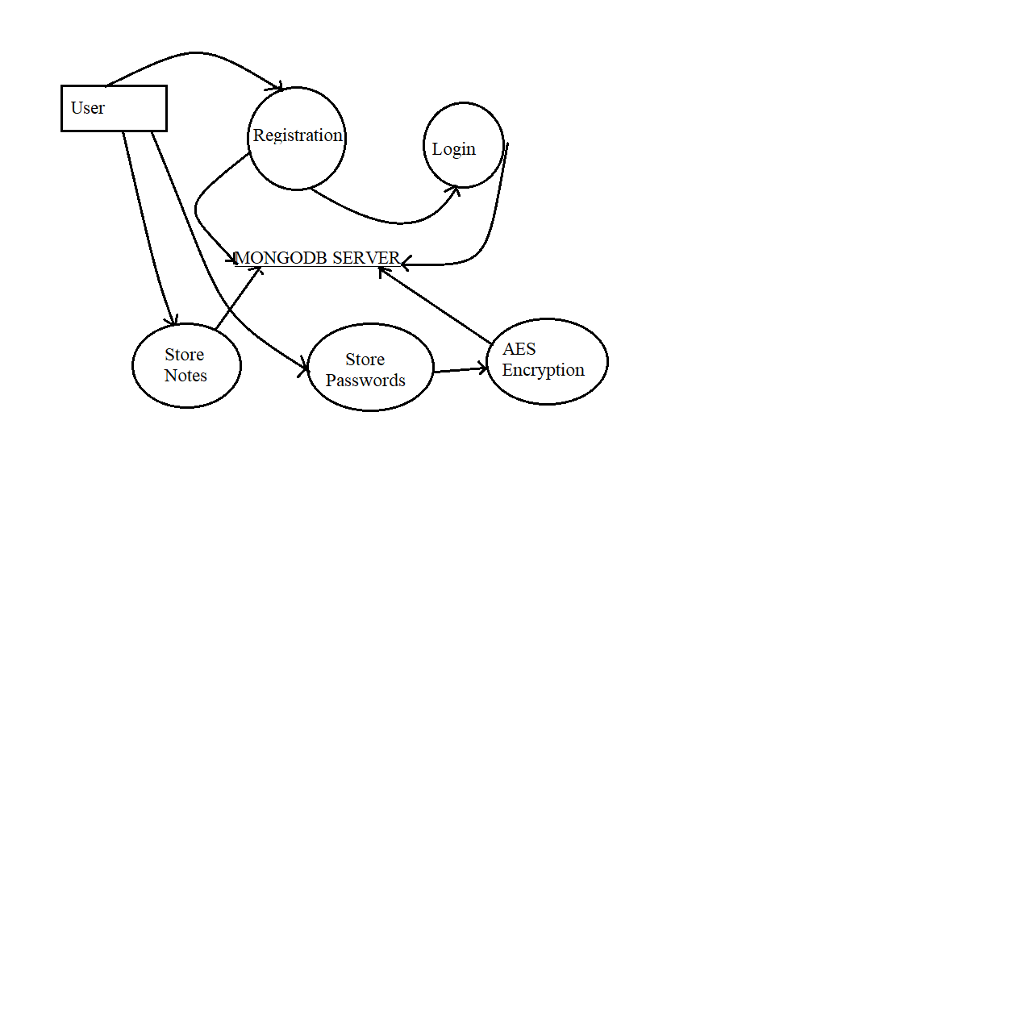

**Fig.1 WorkFlow Diagram of “Digital Dairy”**

**PART 1.** Making *Login and Registration page* and adding functionality of email verification for security-related.

**PART 2.** Designing Internal Interface of website to add password and store notes.

**PART 3.** If User want, he/she can change their account password again.

**PART 4.** Implementation Dashboard to add notes.

**PART 5.** Testing.

* 1. **UML Diagrams**

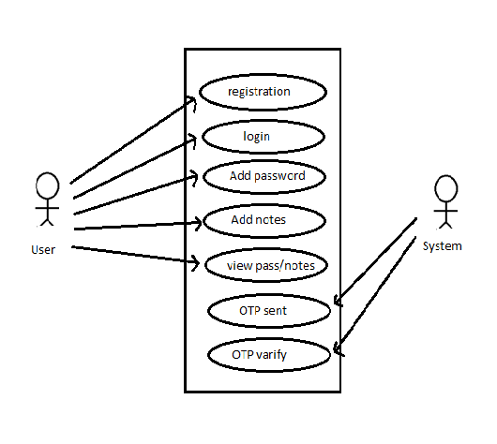

**Fig-2**

**3.2.2 Sequence Diagram**

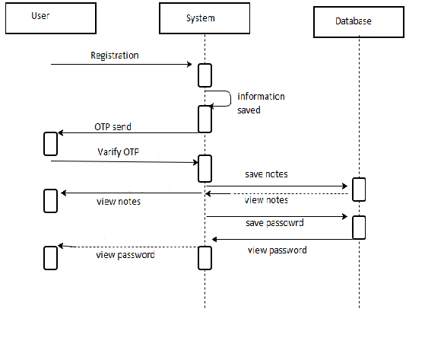

**Fig. 3**

**3.3.2 Database**

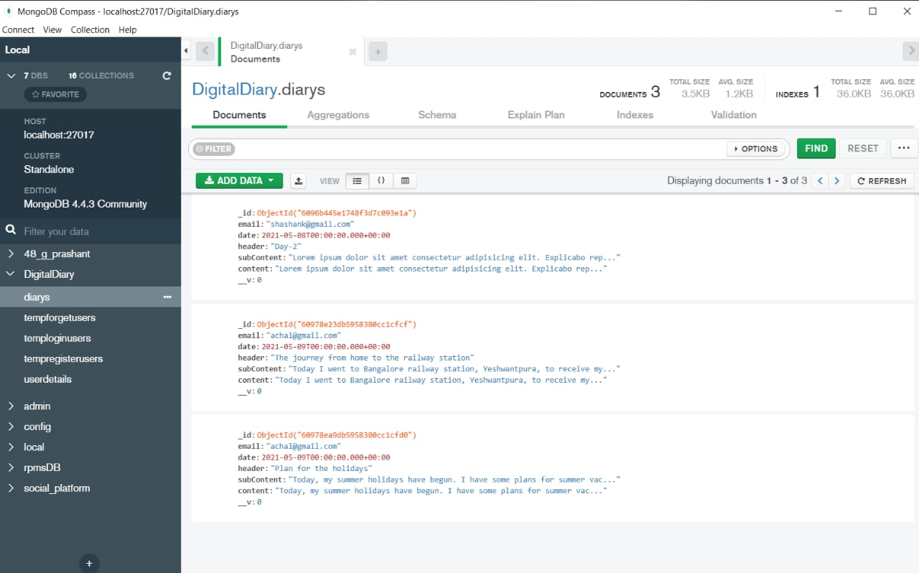

**Img. 1 (database)**

**Chapter 4. Software Testing**

Software testing is an investigation conducted to provide stakeholders with information about the quality of the software product or service under testing. Software testing is a process of executing a program or application with intent of finding the software bugs. It can also be stated as the process of validating and verifying that a software program or application.

Various test cases are as follows:

**4.1 Testing of login session:**

|  |  |  |  |  |  |
| --- | --- | --- | --- | --- | --- |
| **Sr. No** | **Test Cases** | **Feature** | **Description** | **Steps to Execute** | **Test Data/Input** |
| **1.** | **TC-1** | **User Interface** | **Check all the test boxes, radio buttons, buttons etc.** | **1.Click on Radio buttons, buttons and dropdown list** |  |
| **2.** | **TC-2** | **Required**  **Fields** | **Check the required fields by not filling any data** | **1.Do not enter any value in the fields**  **2.Click on Signup button** | **NIL** |
| **3.** | **TC-3** | **Required**  **Fields** | **Check required**  **fields by filling the data** | **1.Enter the valid values in required fields**  **2.Click on Signup button** | **NIL** |

Table No.-1

**4.2 Testing of main session:**

|  |  |  |  |  |  |  |  |  |
| --- | --- | --- | --- | --- | --- | --- | --- | --- |
| **Test**  **ID** | **Testing Method** | **Page** | **Purpose** | **Input** | **Expected**  **Output** | **Actual**  **Output** | | **Result** |
| **T1** | **Equivalence**  **Class Testing** | **Registration**  **Page** | **To check name** | **A-Z and**  **a-z** | **Error**  **message** | **Error**  **Message** | **Pass** | |
| **T2** | **Equivalence**  **Class Testing** | **Registration**  **Page** | **To check name** | **1-9 or @, $, etc.** | **Error**  **message** | **No Error**  **message** | | **Fail** |
| **T3** | **Equivalence**  **Class Testing** | **Registration**  **Page** | **To check**  **Mobile number** | **10 digits** | **Error**  **message** | **Error**  **message** | | **Pass** |
| **T4** | **Equivalence**  **Class Testing** | **Registration**  **Page** | **To check mobile number** | **11 digits** | **No Error**  **message** | **No Error**  **message** | | **Fail** |
| **T5** | **Equivalence**  **Class Testing** | **Registration**  **Page** | **To check**  **City** | **A-Z or**  **a-z** | **Error**  **message** | **Error**  **message** | | **Pass** |
| **T6** | **Equivalence**  **Class Testing** | **Registration**  **Page** | **To check**  **State** | **A-z or**  **a-z** | **Error**  **message** | **Error**  **message** | | **Pass** |
| **T7** | **Equivalence**  **Class Testing** | **Registration**  **Page** | **To check Matric%** | **0-9** | **Error**  **message** | **Error**  **Message** | | **Pass** |
| **T8** | **Equivalence**  **Class Testing** | **Registration**  **Page** | **To check 10+2%** | **0-9** | **Error**  **Message** | **Error**  **message** | | **Pass** |

|  |  |  |  |  |  |  |  |
| --- | --- | --- | --- | --- | --- | --- | --- |
| **T9** | **Equivalence**  **Class Testing** | **Registration**  **Page** | **To check**  **Email** | **a-z+0-9+@+a-z+. +a-z** | **Error**  **message** | **Error**  **message** | **Pass** |
| **T10** | **Equivalence**  **Class Testing** | **Registration**  **Page** | **To check Institute** | **A-Z or**  **a-z** | **Error**  **message** | **Error**  **message** | **Pass** |
| **T11** | **Equivalence**  **Class Testing** | **Login**  **Page** | **To check**  **Username** | **a-z+0-9+@+a-z+. +a-z** | **Error**  **message** | **Error**  **message** | **Pass** |
| **T12** | **Equivalence**  **Class Testing** | **Login page** | **To check** | **0-9** | **Error**  **message** | **Error**  **message** | **Pass** |

Table No.-2

**Chapter 5. Implementation and User Interface**

**5.1 This is the Home page of the project which shows a menu bar showing various buttons and a screen to show the disease as output.**

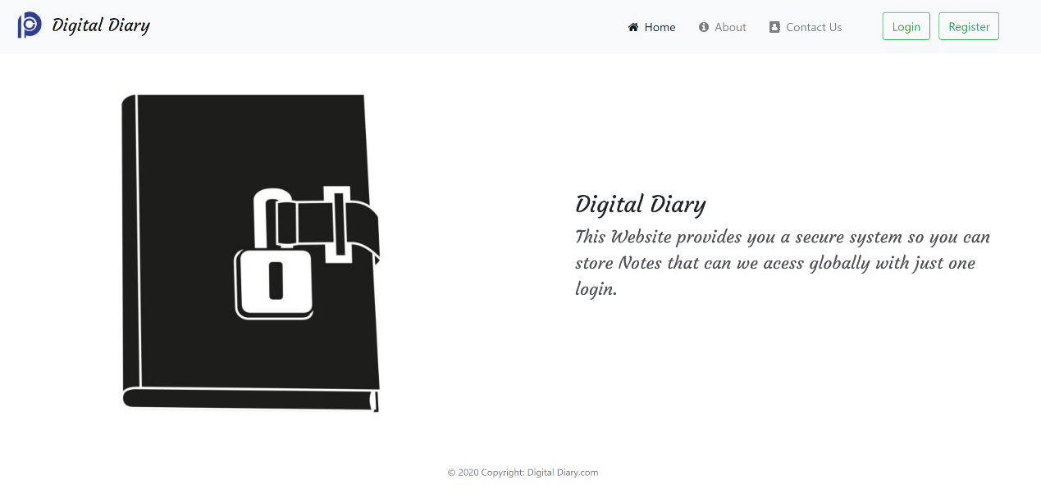

**Fig. 3**

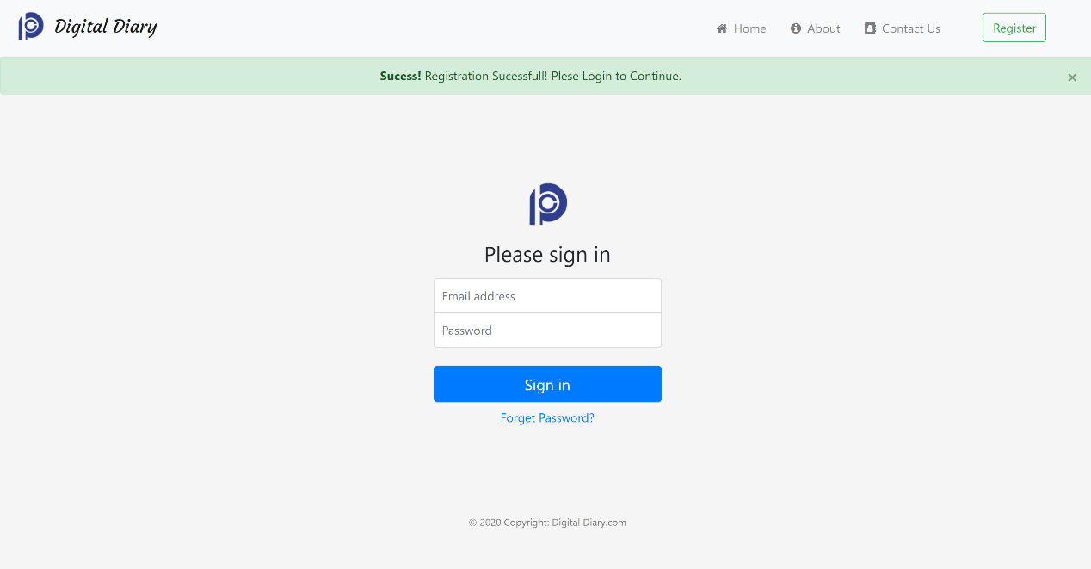

**Fig. 4**

**5.2 - Registration Page**

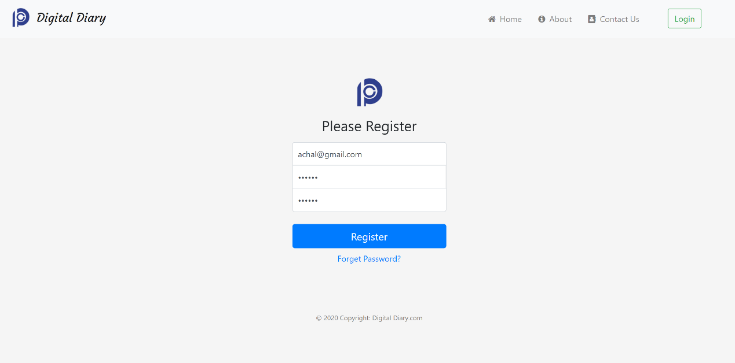

**Fig. 5**

**5.2 - Login Page**

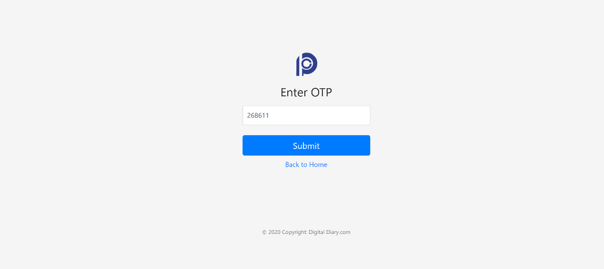

**Fig. 6**

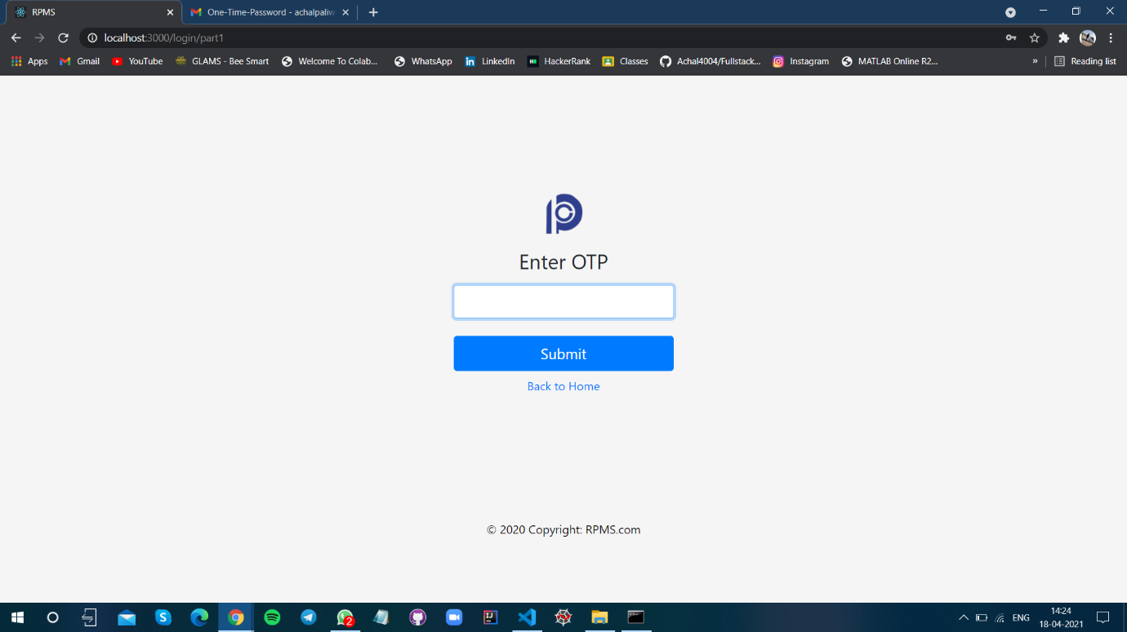

**Fig. 7**

* 1. **Detail Pages**

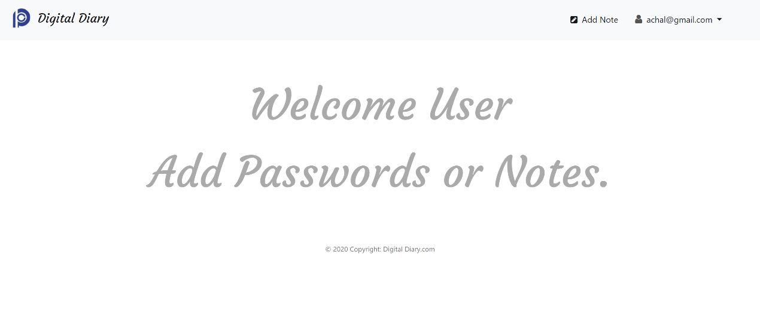

**Fig. 8**

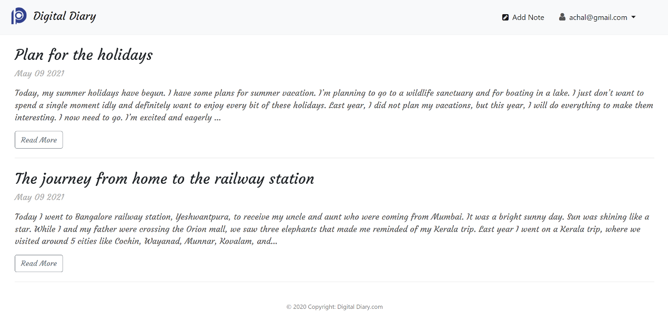**Fig. 9**

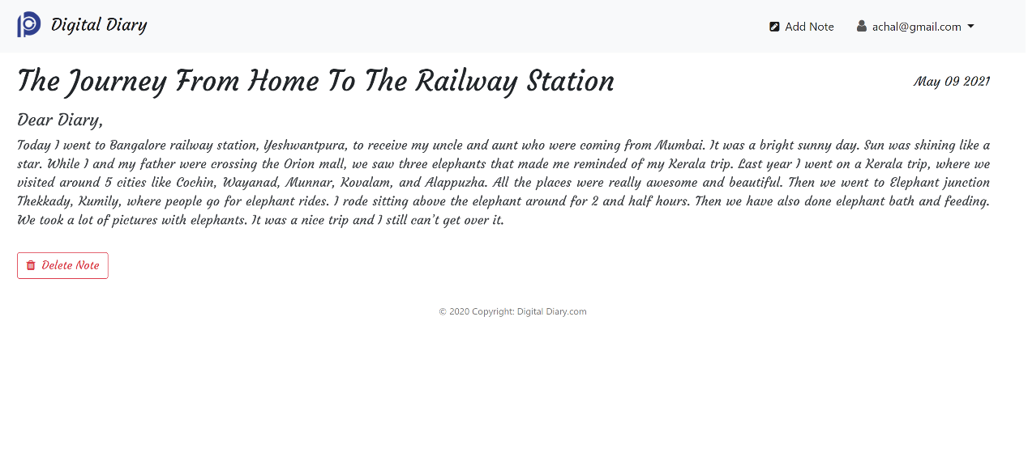

**Fig. 10**

* 1. **Forget password**

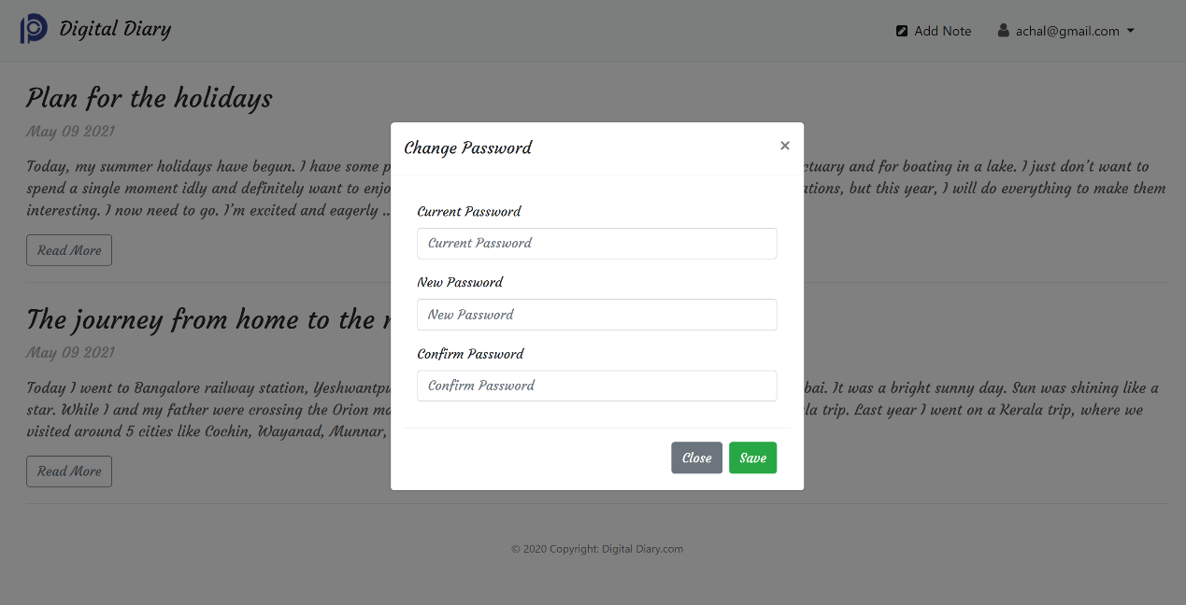

**Fig.-11**

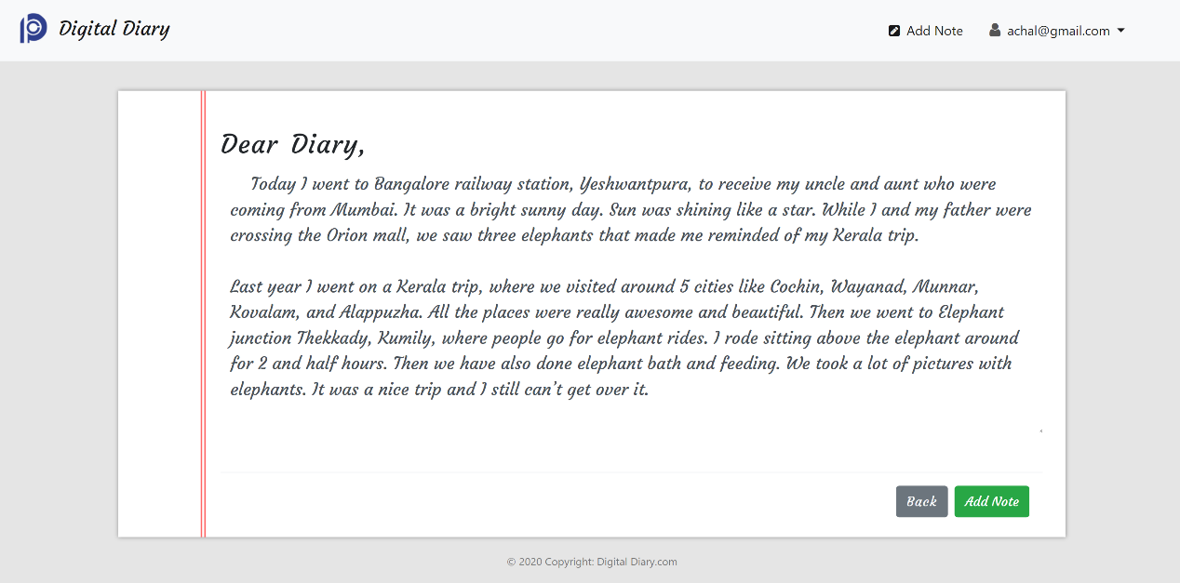

**Fig-12**

**Chapter 6 Appendices**

**Implementation /Coding Part of project:**

require("dotenv").config()

const express = require("express");

const mongoose = require('mongoose');

const session = require('express-session');

const passport = require("passport");

const cookieParser=require("cookie-parser");

const flash=require("connect-flash");

const homeRoute=require('./routes/homeRoute');

const registerRoute=require('./routes/registerRoute');

const loginRoute=require('./routes/loginRoute');

const forgetRoute=require('./routes/forgetRoute');

const app=express();

app.set("view engine","ejs");

app.use(express.urlencoded({extended:true}));

app.use(express.static("public"));

app.use(cookieParser(process.env.SESSION_COOKIES_SECRET_KEY));

app.use(session({ secret: process.env.SESSION_COOKIES_SECRET_KEY,resave: false,saveUninitialized: false,}));

app.use(passport.initialize());

app.use(passport.session());

app.use(flash());

app.use(function(req,res,next){

    res.locals.sorry_msg=req.flash("sorry_msg");

    res.locals.success_msg=req.flash('success_msg');

    res.locals.error_msg=req.flash('error_msg');

    res.locals.error=req.flash('error');

    next();

});

mongoose

.connect(process.env.MONGODB_URIS, {

  useNewUrlParser: true,

  useUnifiedTopology: true,

  useFindAndModify: false,

  useCreateIndex: true,

})

.then(() => console.log("MongoDB Connection Successfull...!!"))

.catch(() => console.log("Error, Not Connected with MongoDB"));

require('./controller/passport')(passport);

app.use('/',homeRoute);

app.use('/register',registerRoute);

app.use('/login',loginRoute);

app.use('/forget',forgetRoute);

app.all('*',(req,res)=> {

    res.render('error404');

});

const PORT = process.env.PORT || 3000

app.listen(PORT,function() {

    console.log("server is listening at port "+PORT);

})

**Contribution**

In this project “Digital-Diary” we have worked as a team. (Achal Paliwal, Prashant Agrawal and Shashank Gupta).

The Back-End Part implementation and is implemented by **Prashant Agarwal** using Express.js, Node, EJS and other back-end technologies.

The Front-End Part, connection, Email Verification (Using OTP) is implemented by **Achal Paliwal** using various front-end technologies like HTML, CSS, JavaScript and EJS.

All documentation Part and Databases and connections of this project is managed by **Shashank Guptas** using monogodb as database.

**Conclusion and Future Scope**

1. **Conclusion:** In this project we have implemented the concept of disgital diary here user can store their important notes so that it can be easy to achieve them anytime anywhere and to maintain security we have used email verification as security purpose.
2. **Future Scope:**  This is web-based project so it works only for internet-based application in future we will try to extend this project for offline also.

**Bibliography/ References**

The following references were used in this project:

1. https: www.beta-labs.org
2. htt[ps://www.geeksforgeeks.org](http://www.geeksforgeeks.org/)
3. https://www.Youtube.com
4. htt[ps://www.wikipedia.org](http://www.wikipedia.org/)
5. https://www.educative.io/